|  |  |
| --- | --- |
|  | **3rd International Conference on Global Education: *Empowering Learners for the Digital Era***  **(ICOGE 2025)**  **13th –14th August 2025** |

# Title -How to Prepare Your Extended Abstract

(Times New Roman, 14 font size, bold, and cantered)

**Author’s Name and Surname1, Author’s Name and Surname2**

(12 font size, bold, cantered)

1. Full address of first author’s affiliated institution (10 font size, cantered)
2. Full address of second author’s affiliated institution

*\*Corresponding author: xxx@lincoln.edu.my (10 font size, left align, and italic)*

**Abstract**

An abstract is a single paragraph, without subheadings, indentation or references. It should be an explicit summary of your presentation that states the problem, the objectives, the methods used, and the major results and conclusions.  It should be single-spaced in 12-point Times New Roman. Do not include bullets/lists or references in the abstract. The abstract should be submitted in the format of MS Word (.doc or .docx) document. Keywords should be given a one-line space below this text.

Keywords: not more than 5 keywords and Keywords should be given a one-line space

## Introduction

There is no indent at the beginning of each paragraph. The space between each subtitle and/or paragraph is one line, as appeared in this guideline. Extended abstract should be composed of introduction and objective, materials and methods, results and discussion, conclusion, and references. Page margins are formed regarding the A4 page size and are 2.5 cm wide from the right, left, top and bottom. Extended abstracts should not below 3 and not exceed 5 pages including the references and pages should not be numbered.

Introduce the subject of interest, address the problem that needs research attention and cite references (Reference, 2010). Please cite references according to year, as in example (Nommik, 1965; Maynard and Hill, 2000; Caliman et al., 2001). The format of references is listed in References. Total number of references must not exceed 15.

Include the objective(s) of the study in the last paragraph of the introduction.

1. **Materials And Methods**

## Subtitle 1

In methodology, include plant materials, treatment structure, experimental design, replications, parameters, analytical techniques, specific types of equipment and its model, city, and country of manufacturing. Please use SI unit and the format for unit is mg/L (not ppm), 50% (no space between ‘50’ and ‘%’), 10 ºC (space between ‘10’ and ‘ºC’).

1. **Results And Discussion**

## Subtitle 1

You may insert table(s)/figure(s) in the text. All tables and figures should be cantered and numbered. Please give a title for the table (Table 1) or figure (Figure 1).

Table 1. Quantitative floral morphological variables of *Carica papaya* plant forms.

|  |  |  |  |
| --- | --- | --- | --- |
| **Variables** | **Male** | **Female** | **Hermaphrodite** |
| Petal width (cm) | 0.25±0.02a (0.10-0.40) | 0.24±0.03a (0.10-0.64) | 0.23±0.02a (0.10-0.64) |
| Ovary length (cm) | 0.61±0.02b  (0.40-0.82) | 0.55±0.06c  (0.20-1.70) | 0.71±0.11a  (0.30-2.10) |
| Ovary width (cm) | 0.10±0.02c (0.05-0.10) | 0.35±0.04ab (0.08-1.00) | 0.39±0.04a  (0.10-0.70) |

Source: Author construct based on the literature findings

Total length 1.14±0.05c 2.23±0.18a 1.92±0.13ab (cm) (0.50-1.50) (1.00-4.89) (1.00-3.30) Mean values in the same row with different alphabets (a>b>c) are significantly different at p<0.05 (ANOVA, Tukey’ test). Values are given in means±standard error and values in bracket are the range. NA- not available.

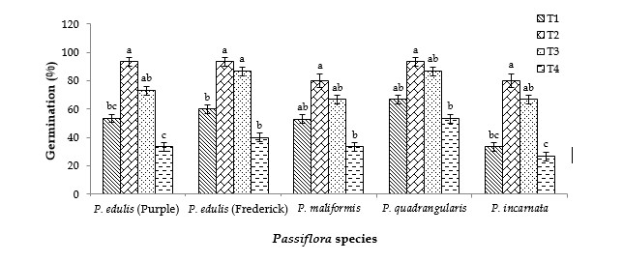

Figure 1. Germination percentage of a) P. edulis Sims (Purple), b) P. edulis Sims (Frederick), c) P. maliformis, P. quadragularis and e) P. incarnata seeds in pregermination treatments of T1= pre-soaked for 24 hours in water, T2= pre-soaked for 7 days in water, T3= pre-soaked for 14 days in water and T4= control.

1. **Conclusion**

Conclude your findings in this section.

## References

Use APA referencing style

ACSB. (2021). *Guiding principles and standards for business accreditation*. <https://www.aacsb.edu/educators/accreditation/business-accreditation/eligibility>

Biggs, J., & Tang, C. (2011). *Teaching for quality learning at university* (4th ed.). McGraw-Hill Education.

Iloanya, J. (2019). Preparing the 21st Century Teacher for the Implementation of Outcomes-Based Education: The Practical Reality. *American Journal of Educational Research*, *7*(7), 439–444. <https://doi.org/10.12691/education-7-7-2>

Mangali, G. R., Biscocho, S. S., Salagubang, M. R. M., Patricia, A., & Castillo, D. (2019). Teaching and Learning Experiences in Letran’ s Partial Implementation of Outcomes